1. **Problem Name:** Validate Container Unloading Sequence Using Stack.

**Problem Code & Output:**

**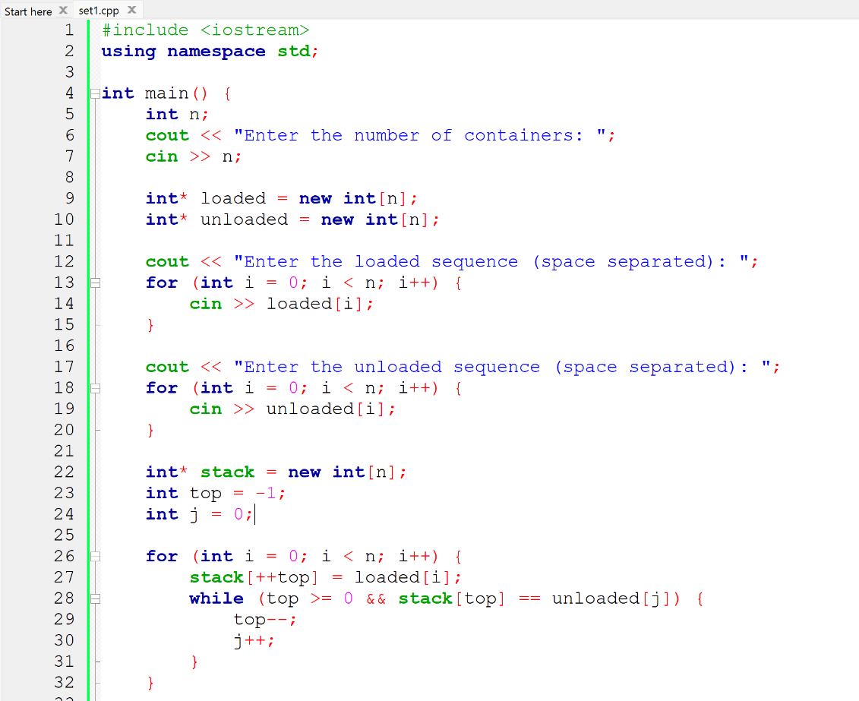  
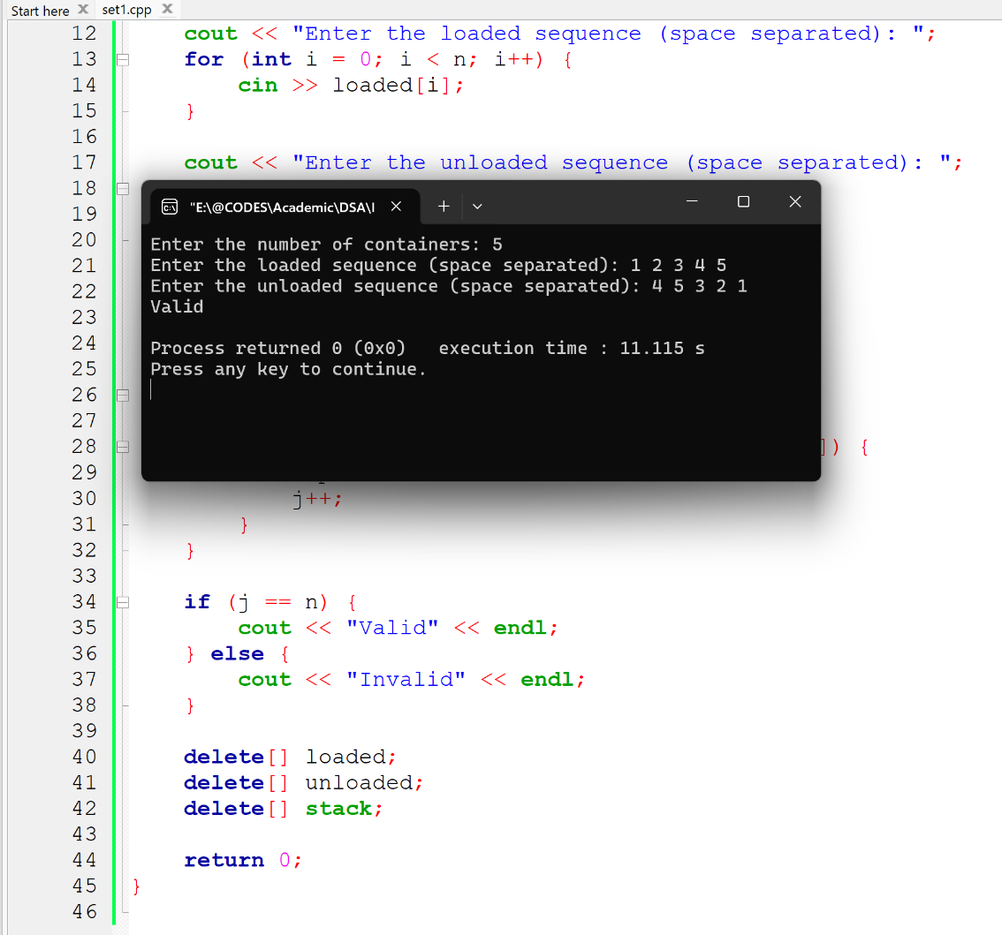**

1. **Problem Name:** Validate Customer Service Sequence Using Queue.

**Problem Code & Output:**

